School Subjects

Match the words with the pictures.

Slovene, Drama, Home Economics, Geography, Art, ICT, Science, German, Music, History, P.E (Physical Education), English, Mathematics, Social Studies, Biology,









__________________ __________________ __________________ __________________ __________________

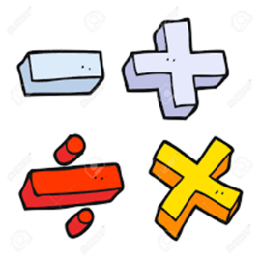







__________________ __________________ __________________ __________________ __________________

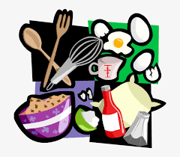







__________________ __________________ __________________ __________________ __________________

**Ask your friend and write their answer.**

1. What is your favourite subject?

_________________________

2. Do you like science?

__________________________

3. Are you good at art?

__________________________

4. Are you interested in maths?

__________________________

5. Are you interested in English?

___________________________

**Complete the sentences by circle your answer**.

1. My favourite subject is __________.
2. I like ______________________.
3. I don’t like _________________
4. I am into _______________
5. I am interested in ______________
6. I am good at ________________
7. I am not good at ________________