What do you do in your free time or at the weekends?
- Match – poveži
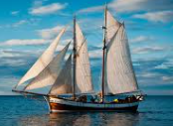 | 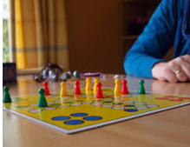 | 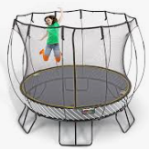 | 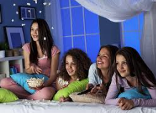 | 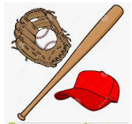
go sailing | play board games | go on a trampoline | have a sleepover | play baseball

- Listening: https://www.youtube.com/watch?v=piwlRwEdhw8
Poveži aktivnosti in imena otrok. V prazne kvadratke vpiši črke ustrezne aktivnosti.
- Thomas | F | - play in the garden, go on a trampoline
- Anita | I | - sleepovers and play board games
- Harriet | C | - making comics, going on PlayStation
- Luke | A | - tennis and stuff
- Grace | D | - go sailing and reading
- Holly | H | - play football
- Jine | B | - watching TV and playing on a trampoline
- Tara | K | - getting my friends on sleepovers
- Uma | G | - go on the computer
- Emma | E | - playing baseball
- Jalib | J | - shopping and swimming

- Work with mum, dad or siblings: Ask and answer.
Delo v družini: Vprašaj mamo, očeta ali brate/sestre in zapiši njihove odgovore.
Ask (vprašaj): | My family member: | His/her answer:
What do you like doing at weekends? | My sister________ | I like going shopping.
 | My mum | I like gardening.
 | My brother | I like watching TV.
- Writing
- On Fridays I like ________________________________________________________
- On Saturdays I like _____________________________________________________
- On Sundays I like ______________________________________________________

