Name:__________________________________________________________________ Date _____/_____/_____

WEATHER



p c l f e m c r f d c y b mm p l a r l s u n n y n o i b q k c v l k l u n d f

i w i n d y d y m g o w b e h w y y p o g w c k k k o d d m h g o h b s n o w y o a l v m s n r z s

t a d v s a j k l m

sunny



cloudy



hot

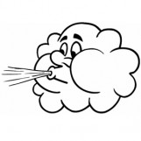 windy 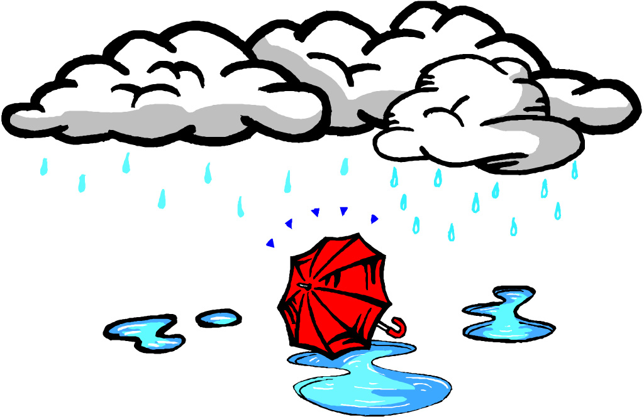 rainy

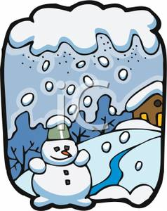 snowy  cold