What's the time? What time is it?/ Koliko je ura?

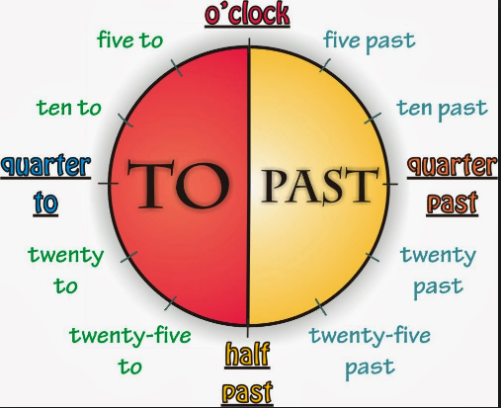
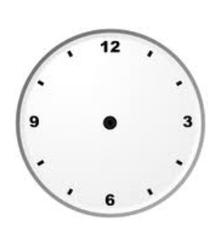
O' CLOCK

It's three o' clock.

HALF PAST

It's half past one.

It's five PAST three.

It's ten PAST three.

It's A QUARTER PAST three.

It's twenty PAST three.

It's twenty-five PAST three.

It's HALF PAST three.

It's twenty-five TO four.

It's twenty TO four.

It's A QUARTER TO four.

It's ten TO four.

h

It's five TO four.

It's four O'CLOCK.

